**Wipro L1 Assignment Architecture**

**Architecture:**

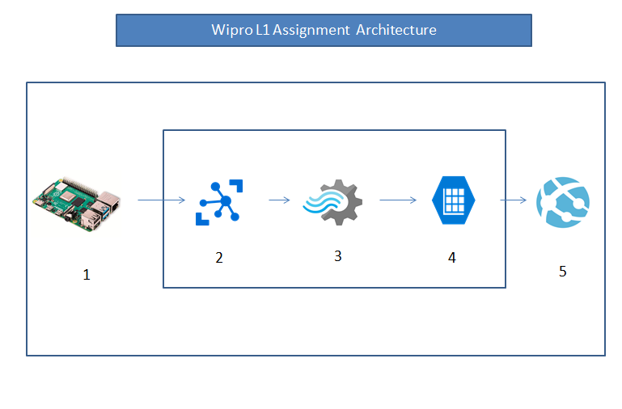

1. Raspberry Pi Web Simulator push data to Azure IoT hub with iothub device connection string.
2. IoT Hub receive data and send it to steam analytics.
3. Stream Analytics will process data and push it to Azure table storage
4. Azure Table Storage will hold the device telemeter.
5. App service will pull data from table storage using node app and show it on web app.

**Components**

1. Raspberry Pi Web Simulator
2. Azure IoT Hub
3. Azure Stream Analytics
4. Azure Table Storage
5. App Service (HTML App hosted on Node Js Server).

**Azure Components**

For building this total setup used azure Wipro digital subscription. Below is the picture for resource group and the resources under it.

Subscription: Wipro Digital

Resource Group: 462wiprotraining (All are free subscription only).

Web Application URL: <https://462manitest.azurewebsites.net/>

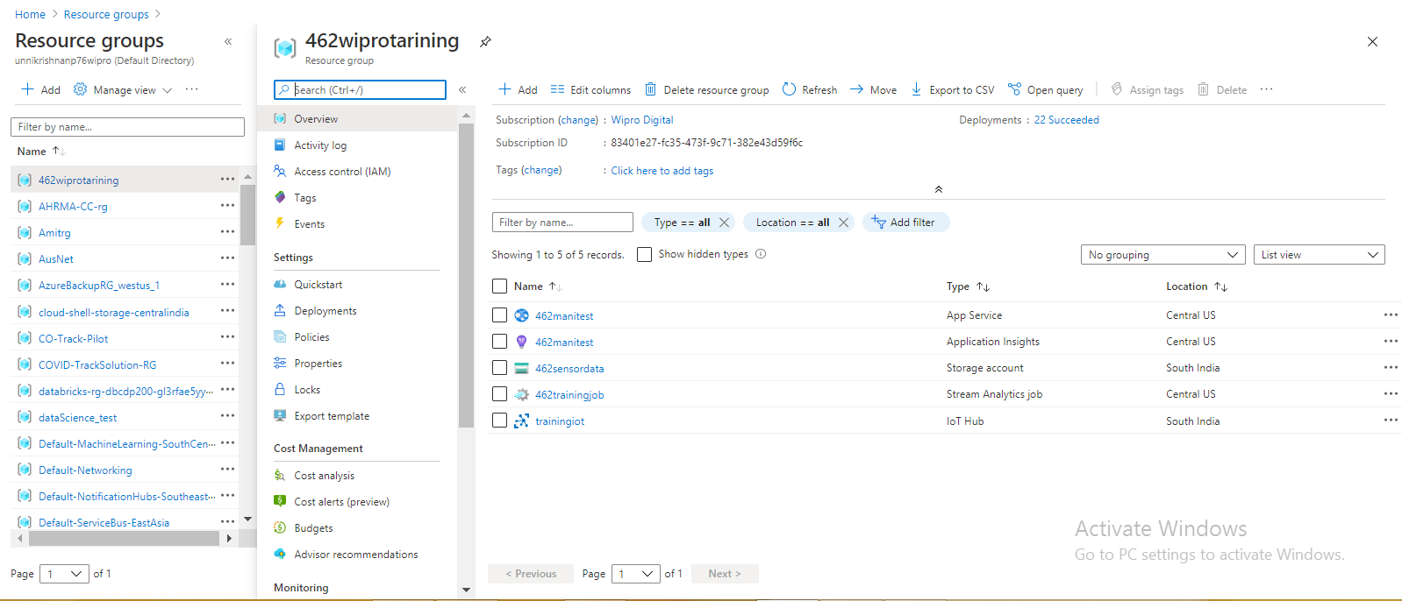

**Functional Flow:**

1. **Raspberry Pi Web Simulator**

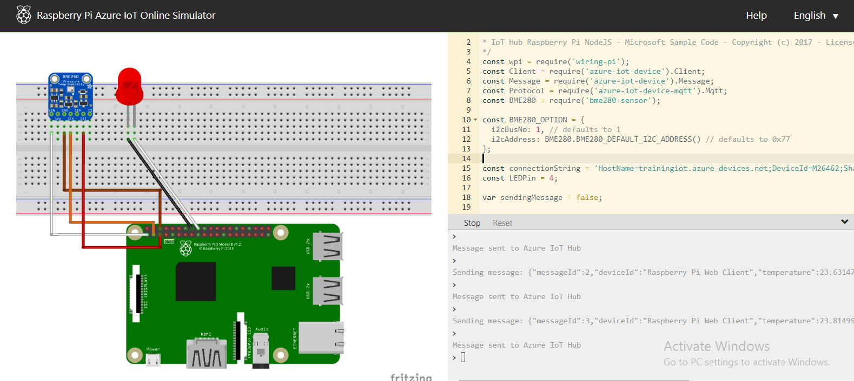

1. **Azure IoT Hub**

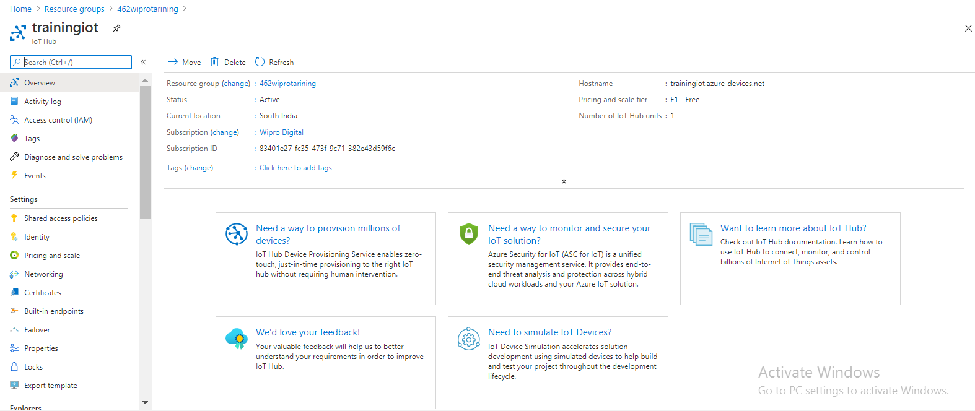

1. **Stream Analytics**

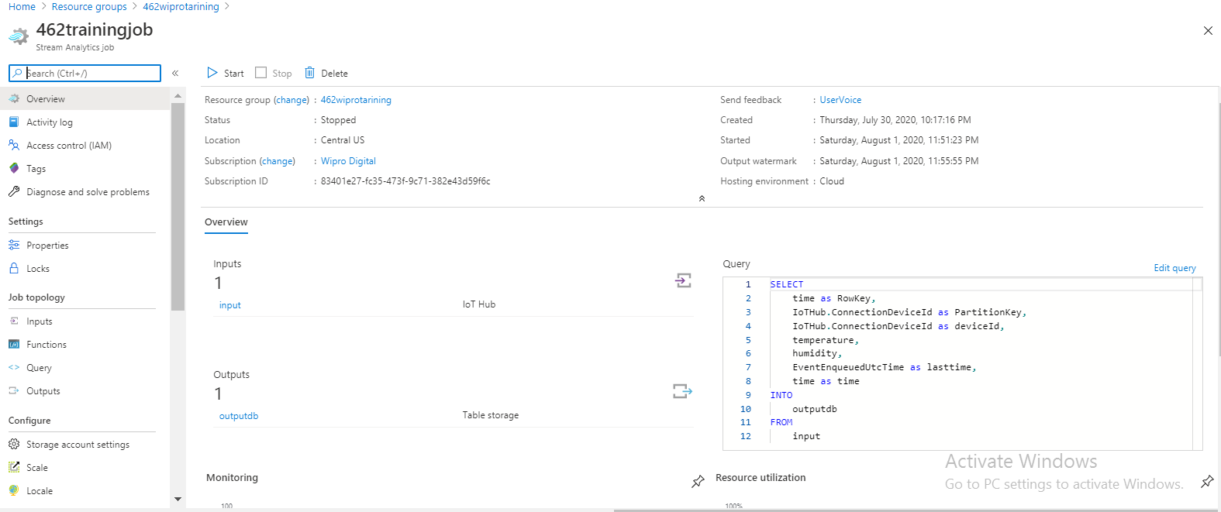

1. **Azure Table Storage**

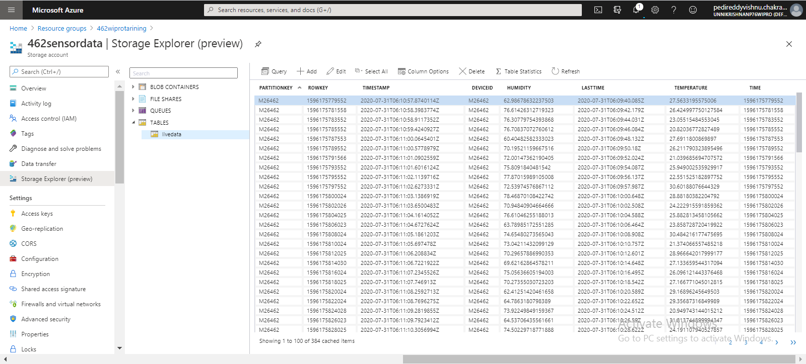

1. **Web Application**

